Formal Report

Pspice Analysis of a Passive ‘Notch’ Filter

By: David Clarke
Course: Electrical & Electronic Engineering2
Date:3/11/99

Abstract

Two aspects of the notch filter are considered. Firstly it is shown that the notch filter in its simplest form is basically an ac bridge, for which at a particular frequency V_{out} (at the centre of the bridge) is at zero potential. Secondly, the use of cascading two filters is described. By having complement device values in both filter circuits, greater accuracy can be achieved in filtering a particular signal. Or else by having each filter set up to filter out opposing magnitude frequencies (i.e.Filter1 filters out 10Hz, filter2 filters out 1MHz), two frequencies can be rejected by the circuit successfully. How close these two reject frequencies can be together for the filtering of two signals to be successful, is investigated and described in the final stages of this report.

Introduction

The purpose of this experiment is an exercise in the use of PSpice to analyse and explain the effect of the notch filter on a particular input signal. The output waveforms obtained can then be used to explain how the system behaves, and what controls its behaviour.

Principles of Methods

All circuits will be analysed using Microsim’s Pspice8.0. The schematic capture facility, is a CAD based package, which creates the SPICE netlist (in the background) and so uses the PROBE facility to create a graphical output.

All bode plots obtained from an A.C. sweep analysis of the circuit (i.e. the circuits voltage response (through Probe the Pspice tool) will be analysed over a broad range of frequencies specified by the user) will take on the form similar to the diagram shown below.

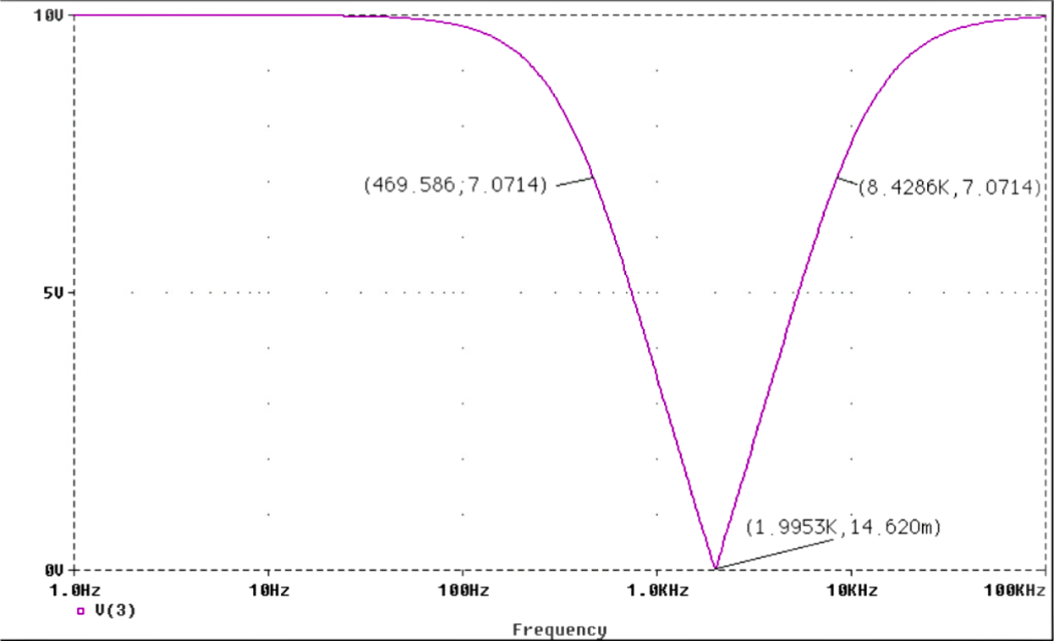
[Graph.1]
Stop Band

Taking Graph.1 as an example the frequency rejected is approximately 2 kilohertz. The peak voltage at V_{out} is equal to the supply voltage which in this case is 10V. It may be assumed that from this point forward, the stop band is a measure of the bandwidth between two points. One on the falling and rising edge of the Bode plot 1/√2 the maximum output voltage (0.707V_{out(max)}).

Results/Discussions of Results and Conclusion

PART1

When the values for the components are set up as shown in Circuit. 1 (captured from part (i) from the problem sheet). It can be seen that the filter rejects a frequency of approximately 160 Hz (see Graph. 15 in the Appendices for graphical representation), i.e. the voltage at the output V_{out} is seen to be at a minimal value, however not zero. But so small in comparison to the input voltage V_{in}, that it is assumed blocked.
The graphical representation shows (using linear, log axes for y and x respectively) that the stop band is symmetrical (visually even) about the rejected frequency. The gradient of the slope from pass band to reject frequency and visa versa, appears linear to a certain extent. In this example from –3db’s down to zero, then up to the –3db’s value on the other side of the graph.

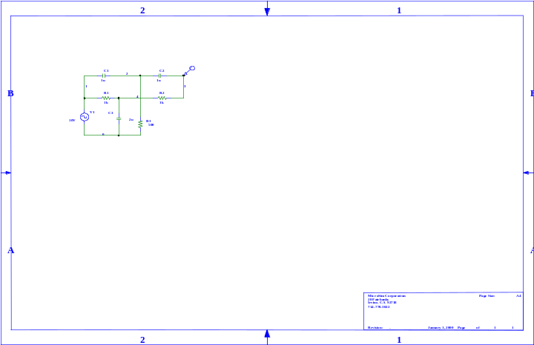[Circuit. 1]

When PSpice is asked to analyse this particular circuit, a net list is created which Probe (the simulator part of the program) uses to picture the circuit. These lines of code are shown below:-

V_V1 1 0 DC 0V AC 10V
C_C3 0 4 2u
R_R3 0 2 500

C_C1 1 2 1u
C_C2 2 3 1u
R_R1 1 4 1k
R_R2 4 3 1k

Looking at the numbered nodes in Circuit. 1. The “negative” end of the ac supply is always referenced to earth, which should always be referred to in PSpice as node 0. So taking node 0 as a starting point, the other nodes can be numbered accordingly.

Taking the first line of the Net list code:

V_V1 1 0 DC 0V AC 10V

Voltage source V1 is attached to node 0 and node 1, the signal it creates has no dc value but has a p-p ac value of 10V. On the basis of this single explanation the line of code used for the other devices can be logically derived.
Probe then analyses the circuit as specified by the user, in this assignment the circuit will be analysed by these means: -

A.C. Sweep
Transient

In the case of the analysis in PART1 of the assignment an ac sweep is used (which is described above).

PART2

Question. What governs the frequency of the ‘notch’?

The systematic process of changing device values to determine what governs the frequency of the ‘notch’ is described in the Appendices.

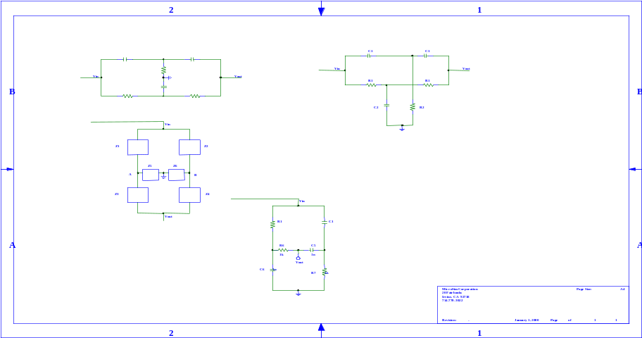A faster and more efficient solution can be found by analysing the circuit carefully. Notice in Circuit. 2 there are two Y networks (okay they look like t’s, just think of them as collapsed Y’s).

[Circuit. 2]

Lets denote the Y network 1 asY₁ this network includes components C1 & R2. Network Y₂ included components R1 & C2. If the two networks impedances are matched in some way, the variable stop band and reject frequency can be altered.

This two Y network is looking more like a bridge. Actually with a few alterations in the preliminary design, that is exactly what this passive notch filter is. Look at Circuit. 3:
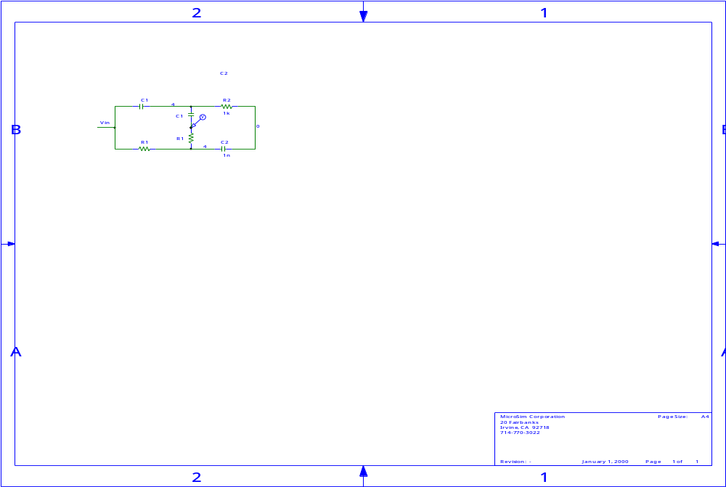
[Circuit. 3]

The circuit in Circuit. 3 functions exactly the same as the circuit shown in Circuit. 2.

It is more commonly shown in text books in a similar fashion to Circuit. 4:
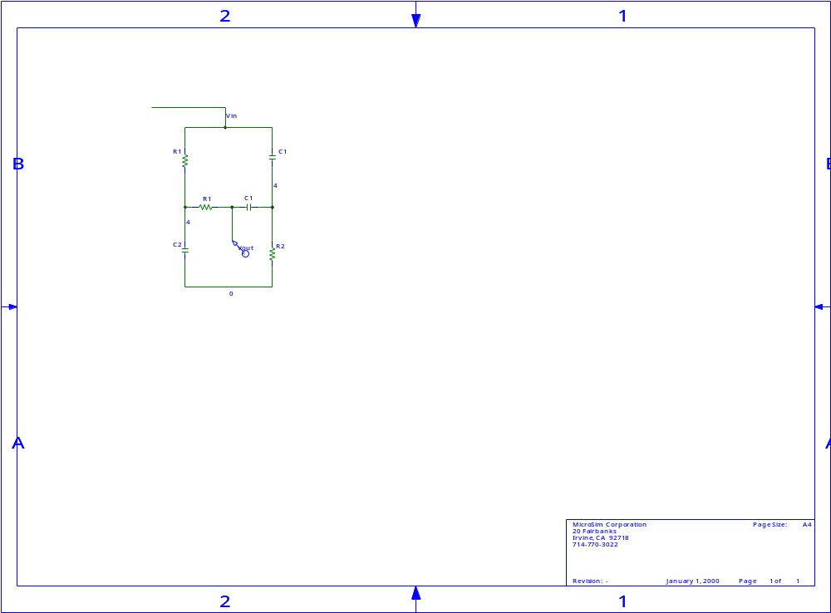
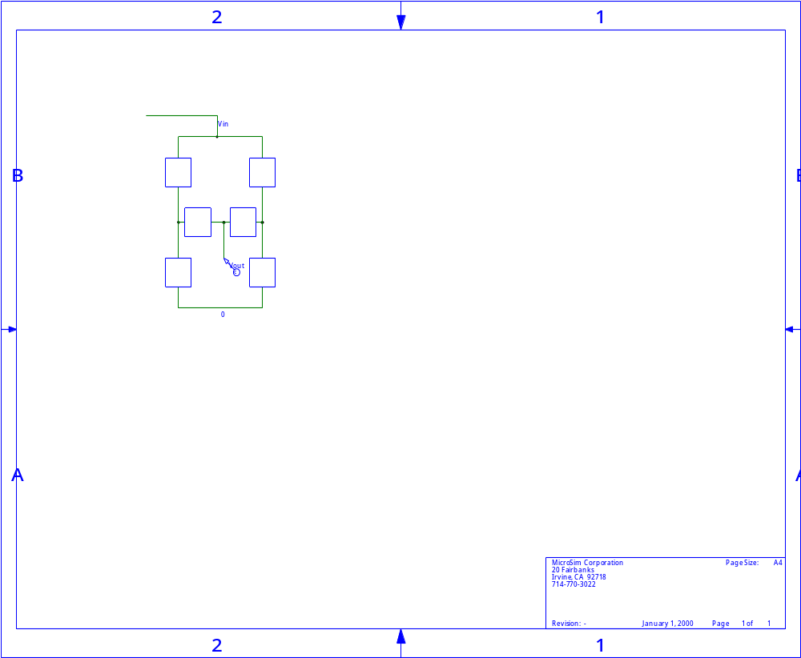
A
A
B
B
[Circuit. 4]

Looking at Circuit.4 the bridge is balanced when the voltage at node A is the same as the voltage at node B, both measured with respect to a common reference. Under these circumstances, V_{AB} = 0 and the current between nodes A and B is zero.

It can be seen that the values obtained for the stop band and reject frequency mirror those values obtained in the previous analysis. If R1 is decreased and C1 increased proportionally to one another (which is exactly the same as increasing R2 in proportion to the decrease in C2) the opposite effect occurs. At the cut off frequency further alterations in these values causes the stop band to narrow, but this has the effect of passing more voltage through. When R2 is decreased in proportion to the increase in C2 such that C2 and R2 are approximately 8 times their original value (i.e. R2's eight times smaller, C2's 8 times larger) the voltage allowed through by the filter is larger than the designated point of cut off (i.e. 7.07 V). Hence when C2 and R2 values are altered to this extent, the filtering action of the circuit is deemed inadequate.

PART3

Designing the filter to cut out a signal with a frequency of 2kHz

The only devices which are frequency dependant in this circuit are the three capacitors. The capacitive reactance of these three will change when the frequency of the A.C. input signal is changed. The filter is set up initially using the convention C2 = 2*C1 and R2 = R1/2. So, C1 and C2 values are required. To calculate the values for C1 and C2, their capacitive reactance’s are needed.

*Refer to Section3 in the Appendices for the full calculation of C1 and C2

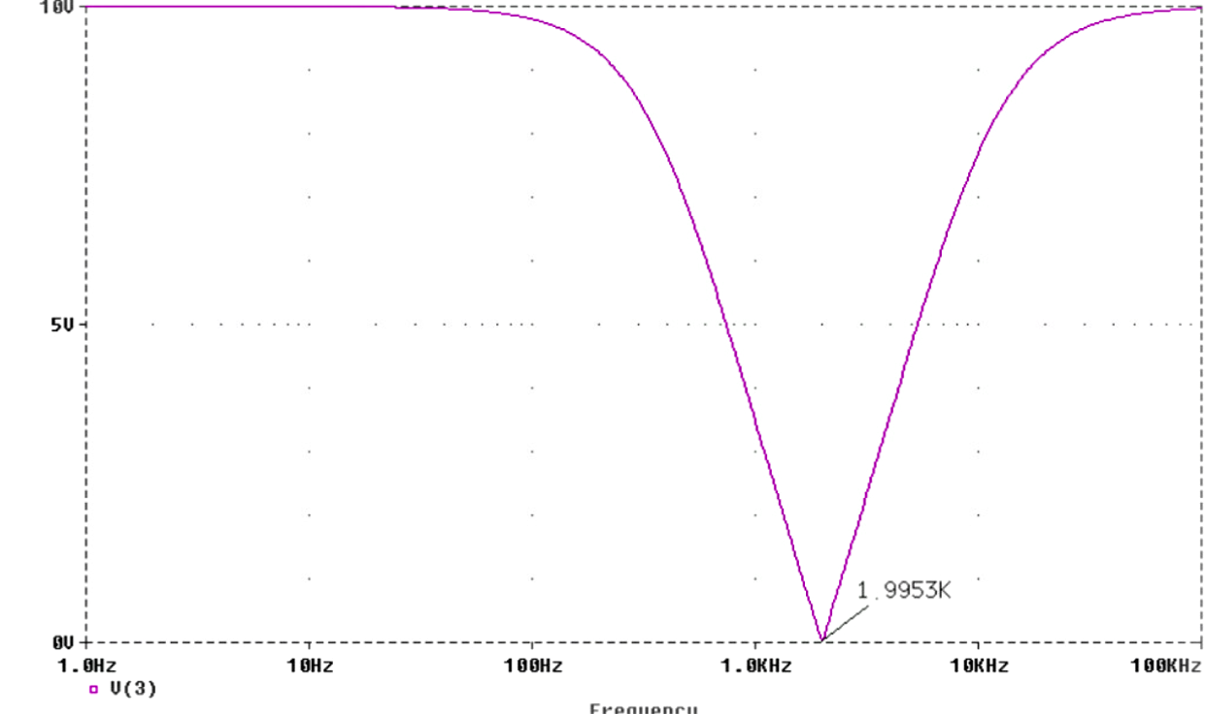
[Graph.2]

The bode plot of Graph. 2 clearly shows a frequency of approximately 2kHz has been blocked.

Analysis of V_{out} when the filter is inputted with Sine waves of frequencies 500, 1k, 2k, 5k and 10k Hz

To inject a sine wave input into the filter circuit, a voltage stimuli needs to used, so by removing the A.C. power supply on the schematic diagram, placing a stimulus with a p-p voltage of 20 volts and with a defined frequency in place, V_{out} can be evaluated. To inspect the frequency response over a specific time domain, a transient analysis of the output is required.

In SPICE’s netlist, the voltage source is seen to be replaced by a stimulus which is given an appropriate name. So for example, a 500Hz sine wave shown in Graph. 3 would have the attributes shown in Figure.1.
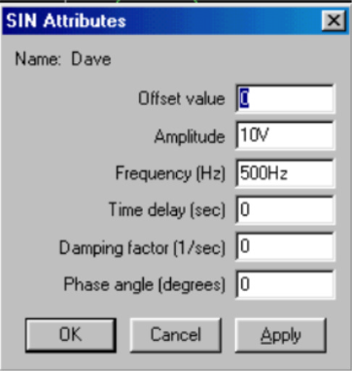
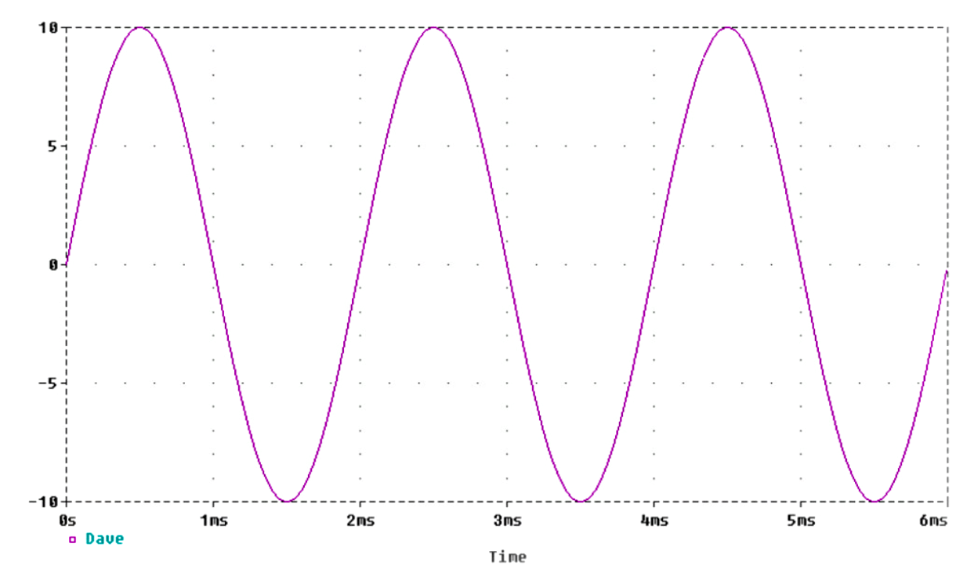
[Graph.3] [Figure.1]

Observing both input and output voltage simultaneously, the relationship between these two plots can be assessed. Shown directly below are the 5 graphs which show how Vout varies in time with a defined frequency input voltage.
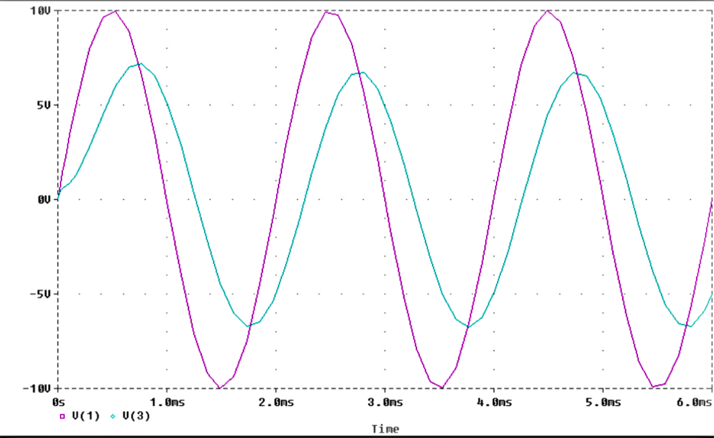
[Graph.4] 500Hz Sine wave input

In Graph. 4 the voltage at V_{out} is clearly smaller than the input voltage Vin i.e. it’s value is reduced to 13.4 V p-p. From the diagram above it can be seen that the output voltage is being filtered somewhat by the action of the circuit.

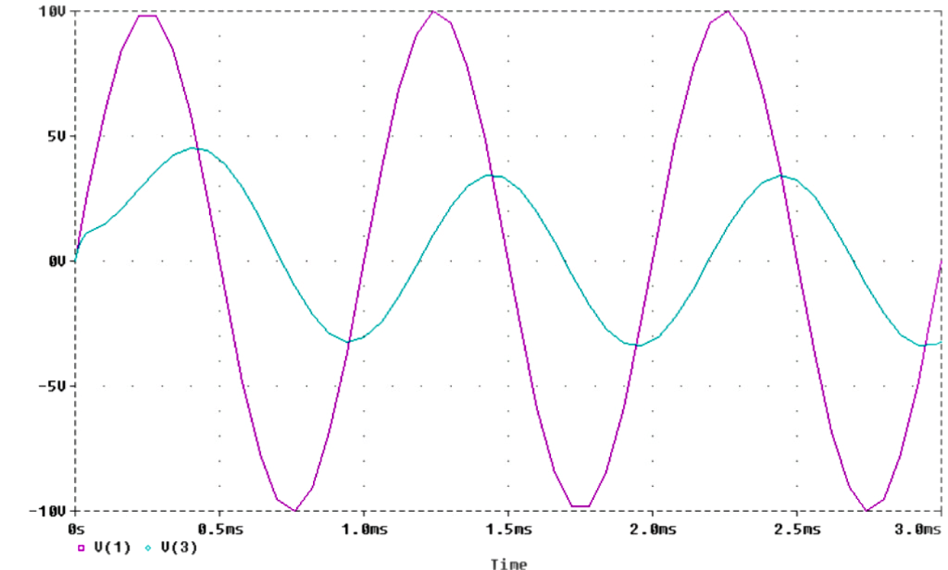
[Graph.5] 1 kHz Sine wave input

In Graph.5 an input signal of 1kHz (twice the frequency of the previous input signal) when inserted into the circuit depletes the output voltage V_{out} to 7.7V, which is nearly half the value of the V_{out} obtained whence using the 500Hz input signal. Notice also the phase of the output voltage is different to that of the input voltage.

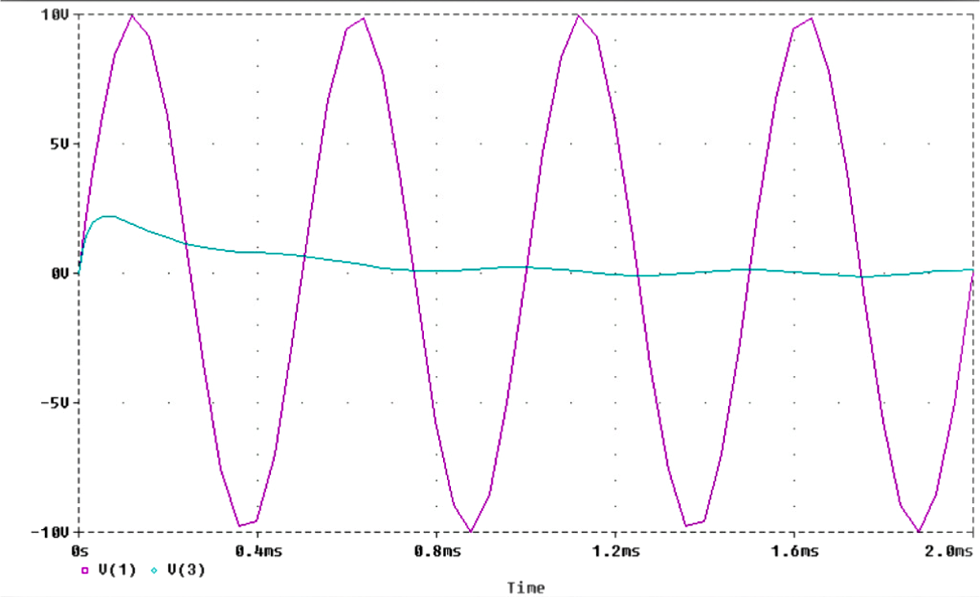

[Graph.6] 2kHz Sine wave input

Notice in Graph.6 the 2khz signal is more or less blocked, which is predictable. The peak to peak voltage of the output signal being less than 1 volt. Notice the slight voltage rise at the start of time of the assessment, this is a characteristic of a settling circuit.

Inputting a 5kHz and 10kHz into the system gives an output from the circuit which is similar to the plots obtained from respectively using a 1kHz and 500Hz signal. Hence mirroring of the output signals can be seen about the 2kHz cut off frequency of the circuit.

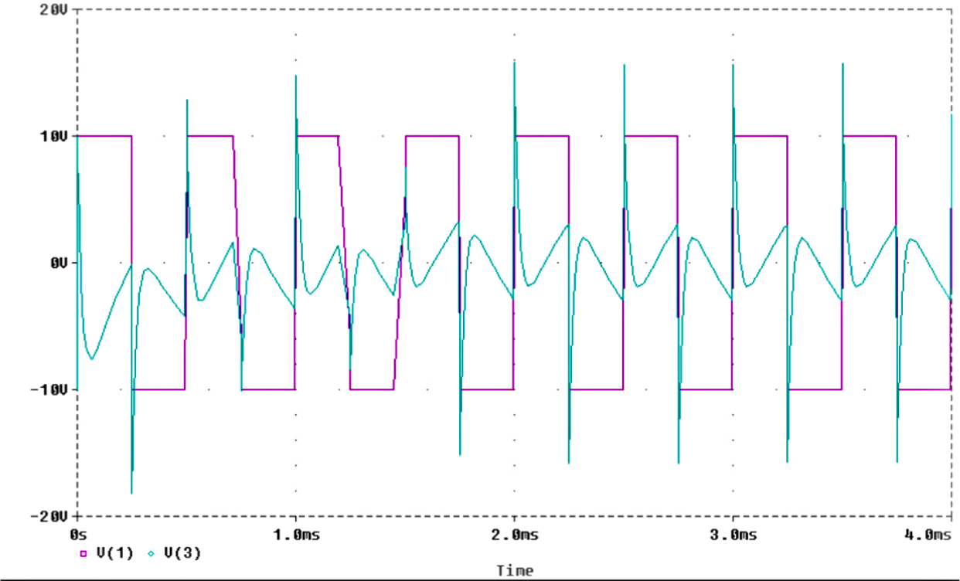
[Graph.7] 2kHz Square wave input

The input waveform was created using a pulsed voltage source in the circuit, with a period of 5x10⁻⁴ seconds and a pulse width of 2.5x10⁻⁴ seconds I.e. which is equal to a wave with a frequency of 2 kHz.
Look at the output waveform (the blue waveform), notice the sharp peaks. These peaks are caused by the charging and discharging of the capacitors within the circuit. The average value of the output waveform is very small in comparison to the input waveform. The filter is however less effective at filtering out a square wave in comparison to a sine wave.

PART4

Question. Is it possible to improve the filtering effect by cascading two filters?

A net list of device values which are used in the cascaded filter network are shown below. These particular device values are used to filter out a sine wave of frequency 2kHz.

R_R2 4 3 1k
R_R3 0 2 500
R_R4 3 7 1k
R_R5 7 6 1k
R_R6 0 5 500
R_R1 1 4 1k
C_C1 1 2 0.08u

C_C3 0 4 0.16u
C_C2 2 3 0.08u
C_C4 3 5 0.08u
C_C5 5 6 0.08u
C_C6 0 7 0.16u
V_V10 1 0 DC 0V AC 10V

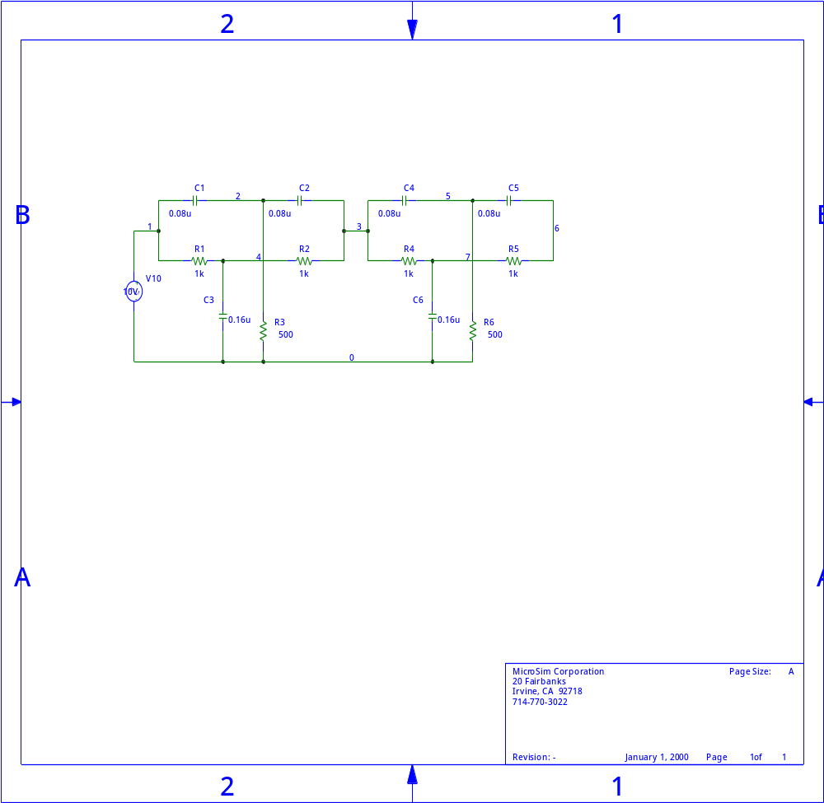
[Circuit. 5] Cascading two notch filters

By setting up the two filters in series with component values used in PART2, the response to input voltages are as follows:
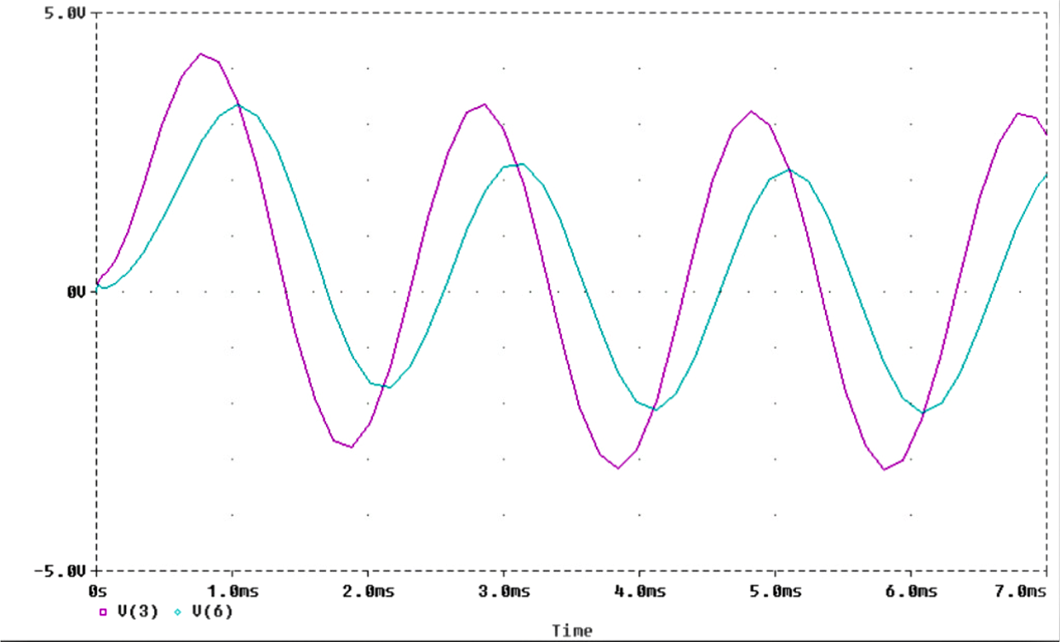
[Graph.8] Filtering a 500Hz input signal. Single filter (pink), cascaded filter (blue).

Graph. 8 shows the effect of having two filters in series has on a 500 Hz signal. In comparison to the output signal produced from the single filter, the amplitude of the waveform from the cascade of filters is approximately three quarters that.
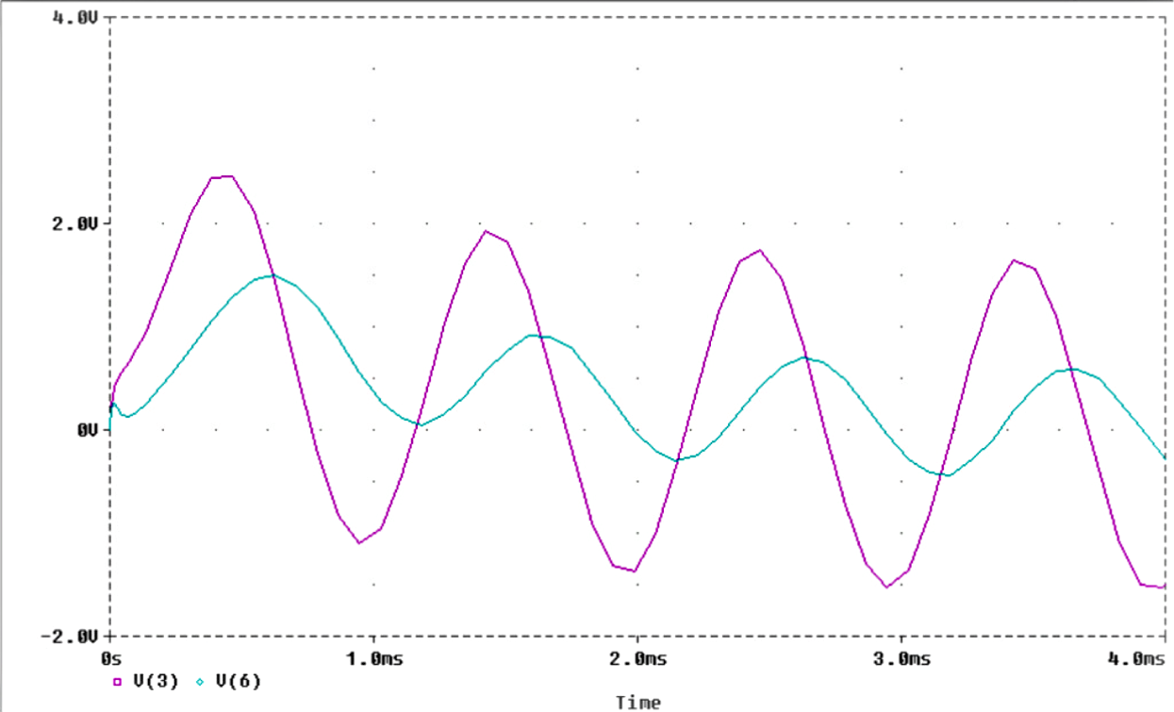
[Graph.9] Filtering a 1kHz input signal.

In Graph.9 taking the pink waveform as the output of the first filter and the blue waveform to be the output of the second filter. The effective filtering of the 1kHz signal by cascading the filters is approximately double.

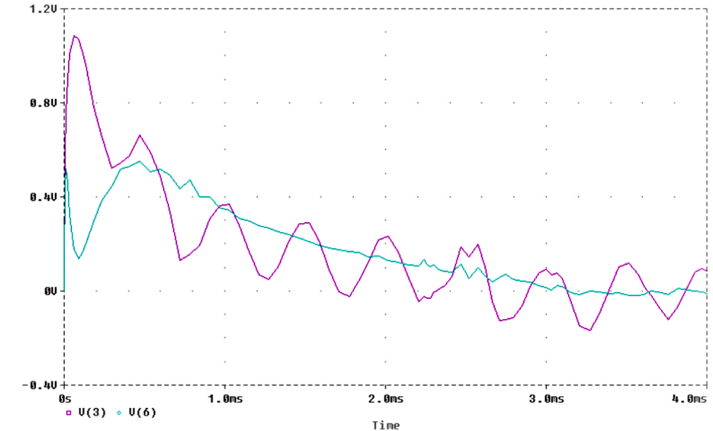
[Graph.10] Filtering a 2kHz input signal. Single filter (pink), cascaded filter (blue).

The notch filter in this part of assignment was designed to cut out a frequency of 2kHz. Observe the scale on the y-axis, the cascaded filter, filters out the 10V input voltage, producing at V_{out,} mV’s p-p output voltage. Comparison of the two filters is shown. Notice the effective filtering of the cascade of filters is far, far greater than the single filter this time round.
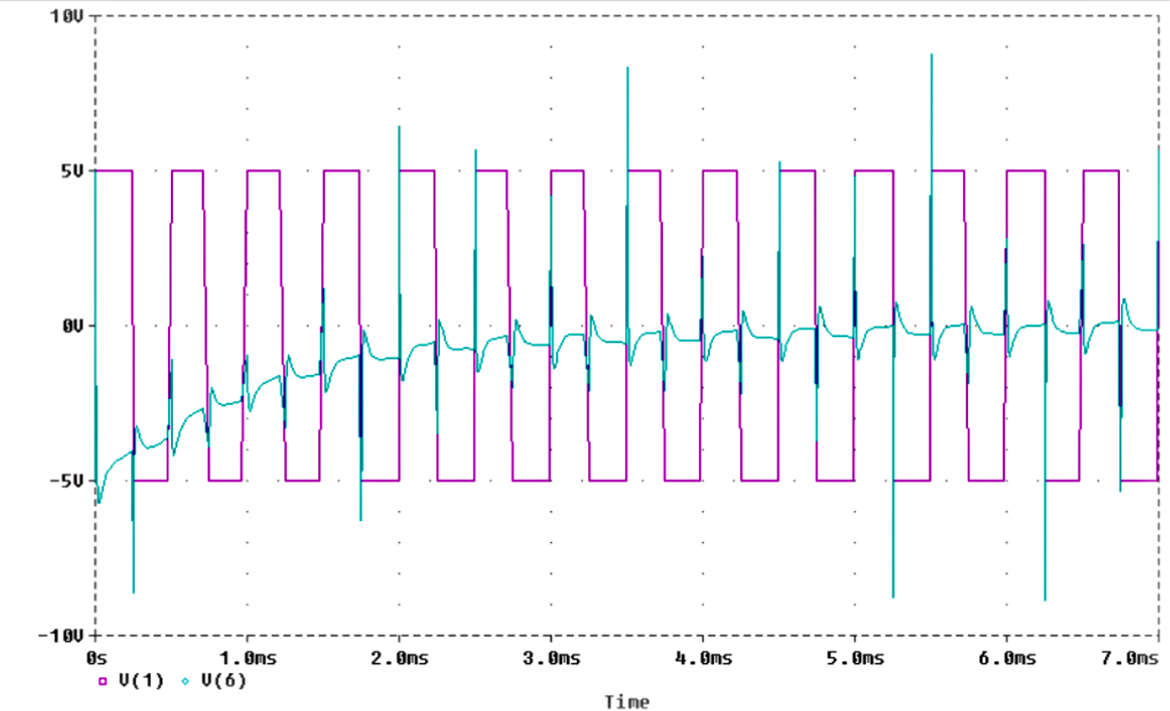
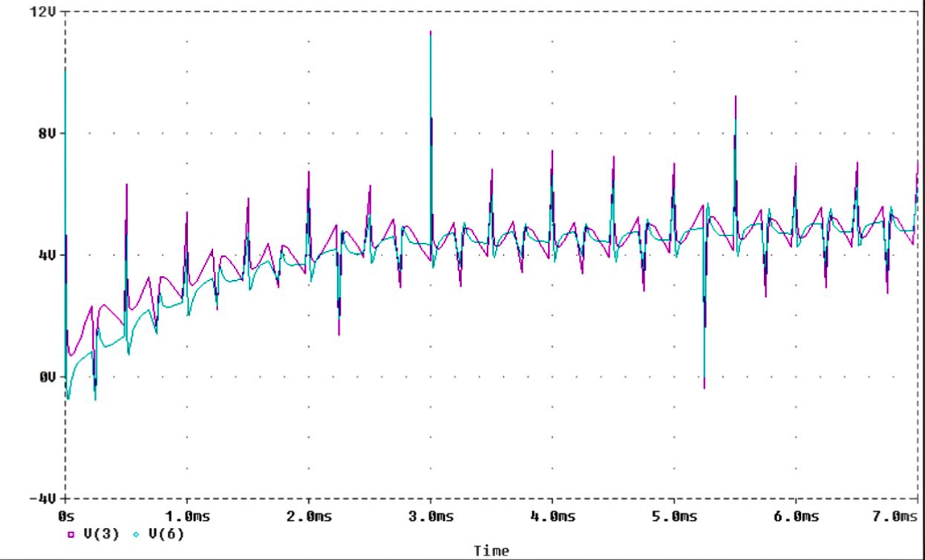
When increasing the frequency of the input signal to 5/10 kHz the bode plots produced very much resemble those of the 500/1 kHz bode plots respectively. As before with the single filter, a mirroring of output signals can be seen above and below the 2kHz cut off frequency of the circuit.
[Graph.11] V_{in} (Pink), V_{out} (Blue) [Graph.12] . V_{out}, single & cascade
Graph. 11 shows how the output voltage of the cascade of filters compares with the input voltage V_{in} (2kHz 10V p-p square wave). While Graph. 12 shows the comparison of the output voltage of the cascade of filters against the output voltage of the first filter. The V_{out} waveform produced by the cascade of filters (blue waveform) shown in Graph. 12 is approximately the same as the V_{out} waveform displayed by it’s cousin the single notch filter (pink waveform), but the cascade of filters rejects the frequency more effectively.
The peaks on the output waveform are produced on the positive and negative transition of the square wave impulse, this is created because the input voltage to the circuit changes almost instantaneously, which unsettles the charge stored on the capacitors .

The effectiveness of blocking out a particular frequency by cascading two filters, is obviously an enhanced over the single notch filter. It can be seen when the circuit is set up to centre it’s rejection of frequencies around a known frequency. The effectiveness of the ‘cascade’ becomes much greater when the circuit is introduced with signals of frequencies which approach closer and closer to the reject frequency. As seen in PART4 the ‘cascade’ was more advantageous at filtering a signal when the input frequency signal of 1kHz was used compared with the use of the 500Hz input signal.

PART5

Question. Is it possible to remove two different frequencies by cascading two filters?

In the previous exercise two filters in series were used to filter out one defined frequency. Now, if the first filter is used to filter out a low frequency of say 100Hz, and the second filter is used to filter out a very high frequency of 1 MegaHertz, the appropriate capacitance values will need to be changed in order to filter these out. The calculation steps needed to do this are described in Section.4(1) of the appendices. The circuit is then simulated through Pspice using the A.C. sweep utility.

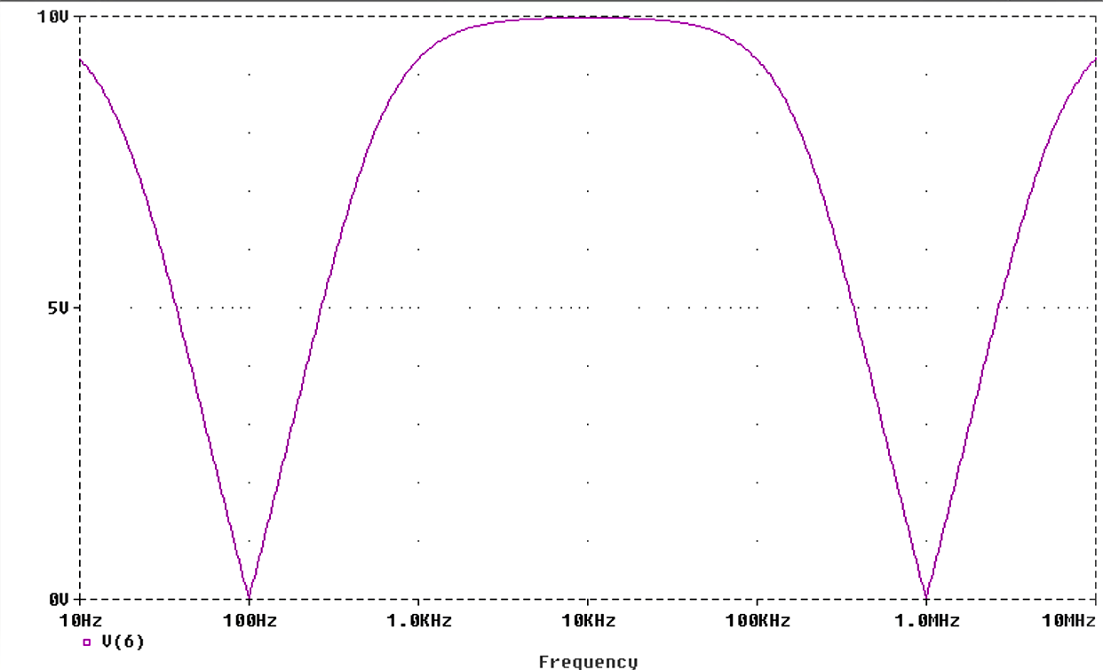
[Graph.13] A cascade of filters rejecting frequencies of 100 & 1MHz.

When the above reject frequencies are used (described at the start of PART5), the cascaded filter, rejects these frequencies fully, by trial and error it can be shown what the limit of the cascaded filter is for filtering out two frequencies.

*These trials and errors are described in Section.4 of the Appendices.

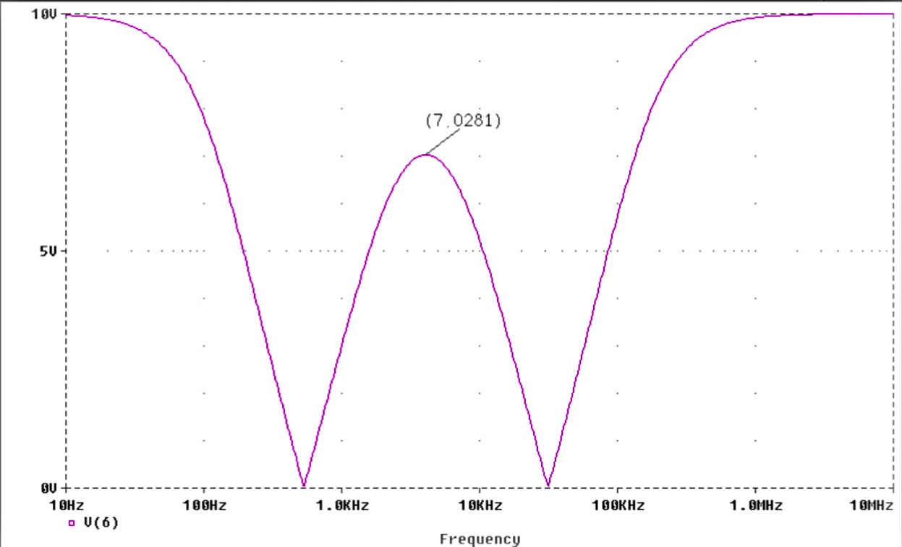
[Graph.14] The cascade of filters coping with the reject frequencies of 531.25 & 31.25kHz
Ratio = 60 : 1

Graph.14 in my view is the filter taken to its limits, it is now ineffective due to the middle pass band not passing 7.07V or more. Thus the ratio of upper to lower reject frequency in this case is approximately:

31.25 x 10³ : 531.25 = 60 : 1

I.e. when the upper to lower reject frequency is 60 : 1 or smaller. The filter is deemed ineffective.

Main Conclusions

- If R1 is decreased and C1 increased proportionally to one another (which is exactly the same as increasing R2 in proportion to the decrease in C2), further alterations in these values causes the stop band to narrow, but this has the effect of passing more voltage through.
- When inputting a 2kHz 20V p-p square wave into the notch filter. The average value of the waveform at the output is very small in comparison to the input waveform. The filter is however less effective at filtering out a square wave in comparison to a sine wave.
- When the ‘cascade’ is set up to cut out a frequency of 2kHz the effective filtering of the is far, far greater than filtering using a single filter.
- The effectiveness of the ‘cascade’ becomes much greater when the circuit is introduced with signals of frequencies which approach closer and closer to the reject frequency.

References

- D.E Gray, ‘Writing a Technical Paper’, Physics Education, 1967, Vol. 2, p. 81-88

- Signals and systems Continuously assessed work, Scientific Paper, 1999

- Electric Circuits, Theodore.F.Bogard, 1992, second edition, p. 598-599

